MA374 Assignment 7

Nikhil Agarwal
11012323

2. Plot of call option by varying s:-

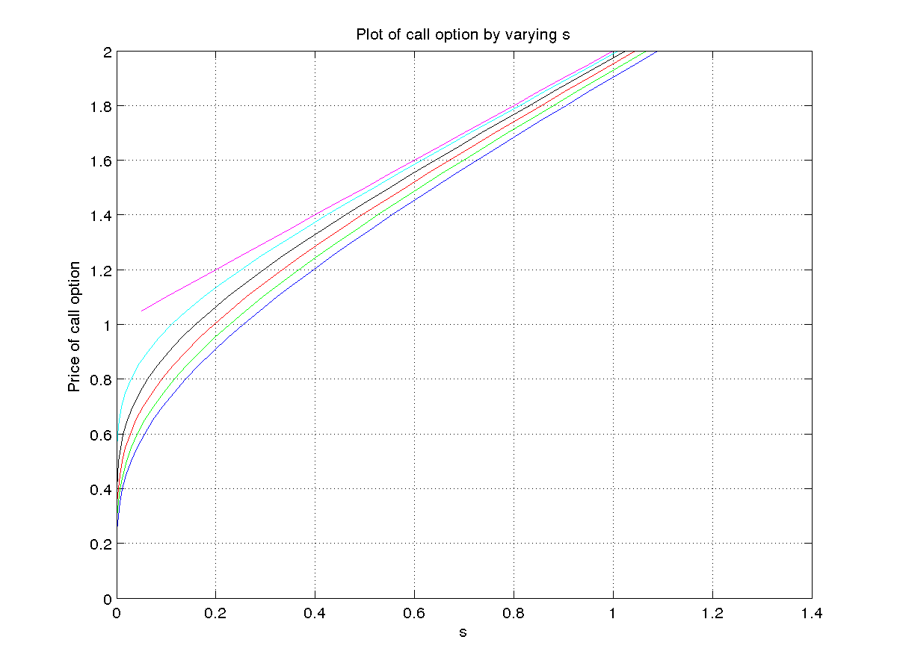
Plot of put option by varying s :-
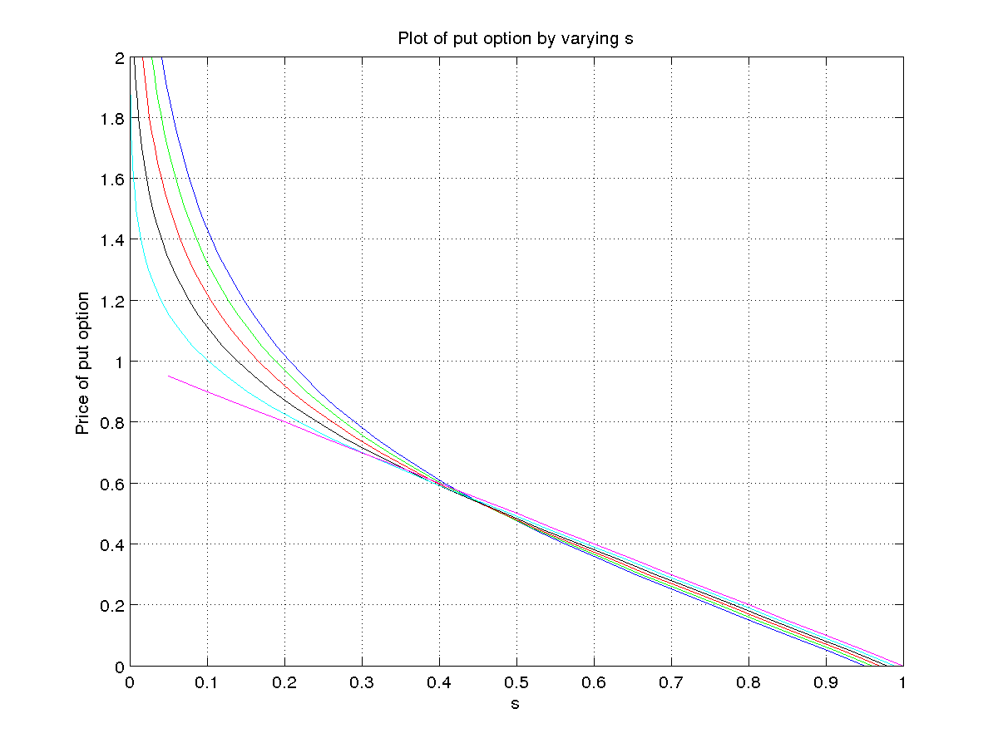
3D Plot of call option by varying s :-
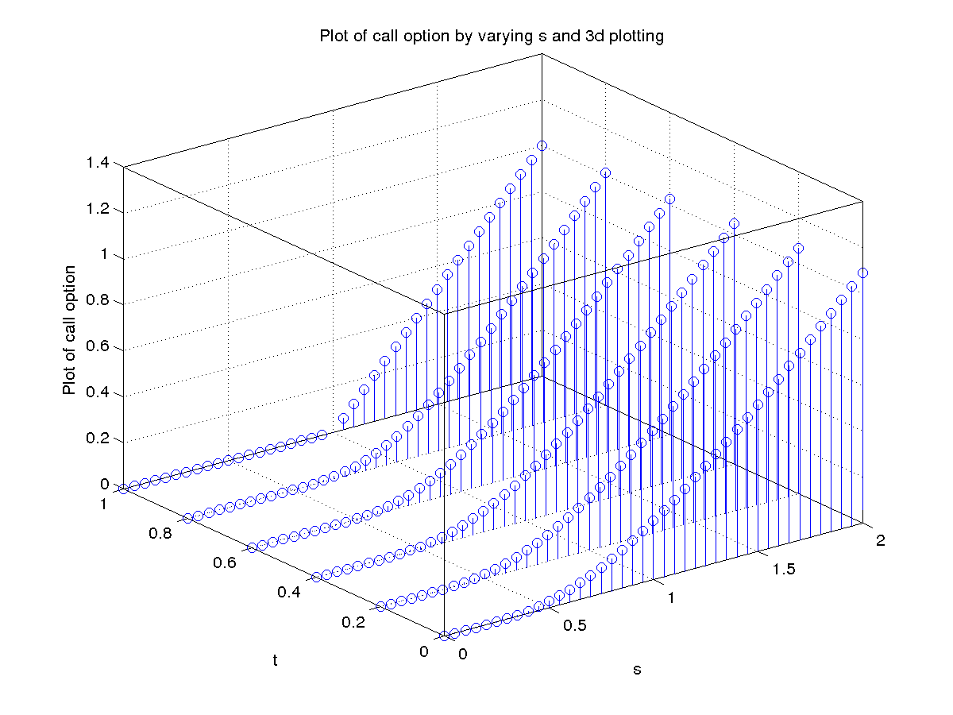
3D Plot of put option by varying s :-
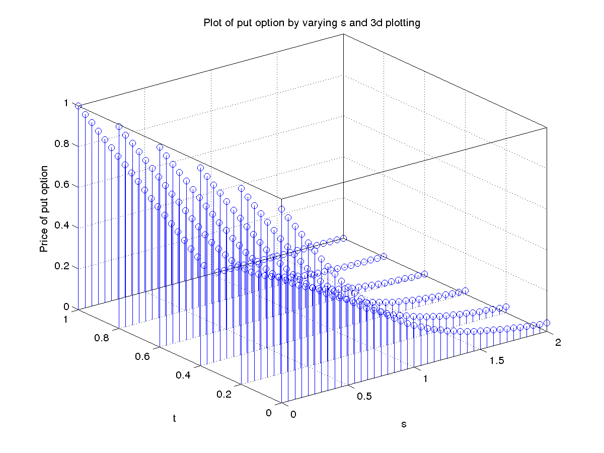
3. Plot of call option by varying s and t :-
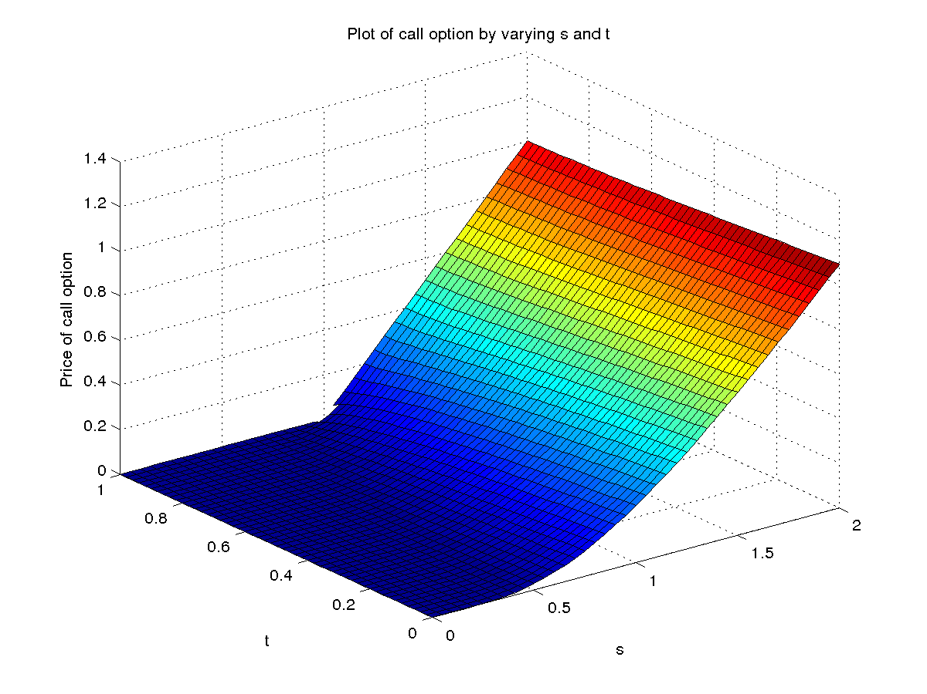
Plot of put option by varying s and t :-
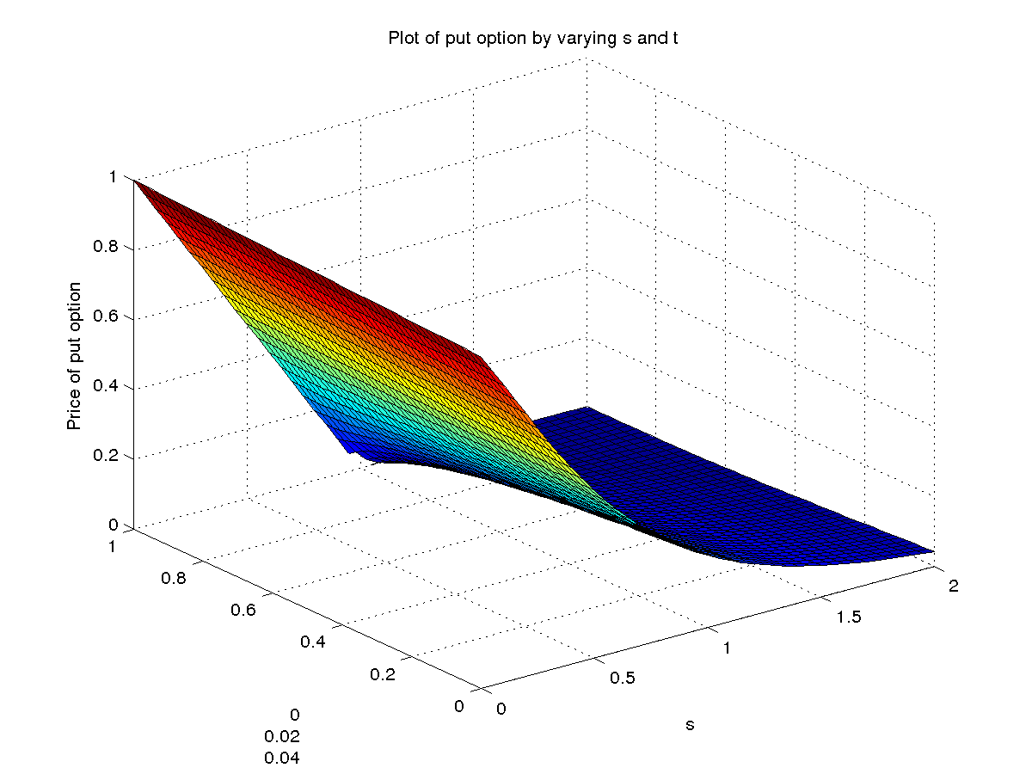
4. Sensitivity of C for changes in Stock Price :-
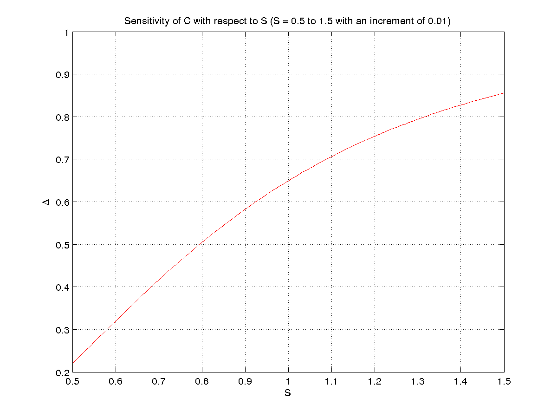
Sensitivity of C for changes in σ :-
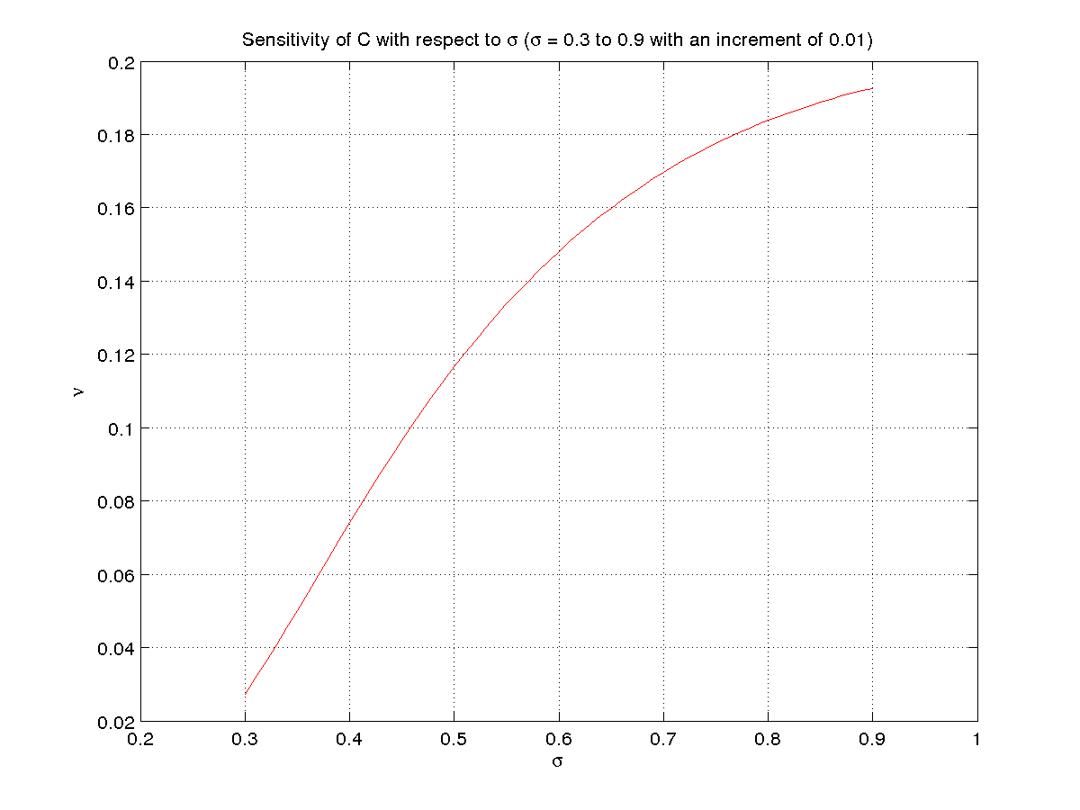
Sensitivity of C for changes in t :-
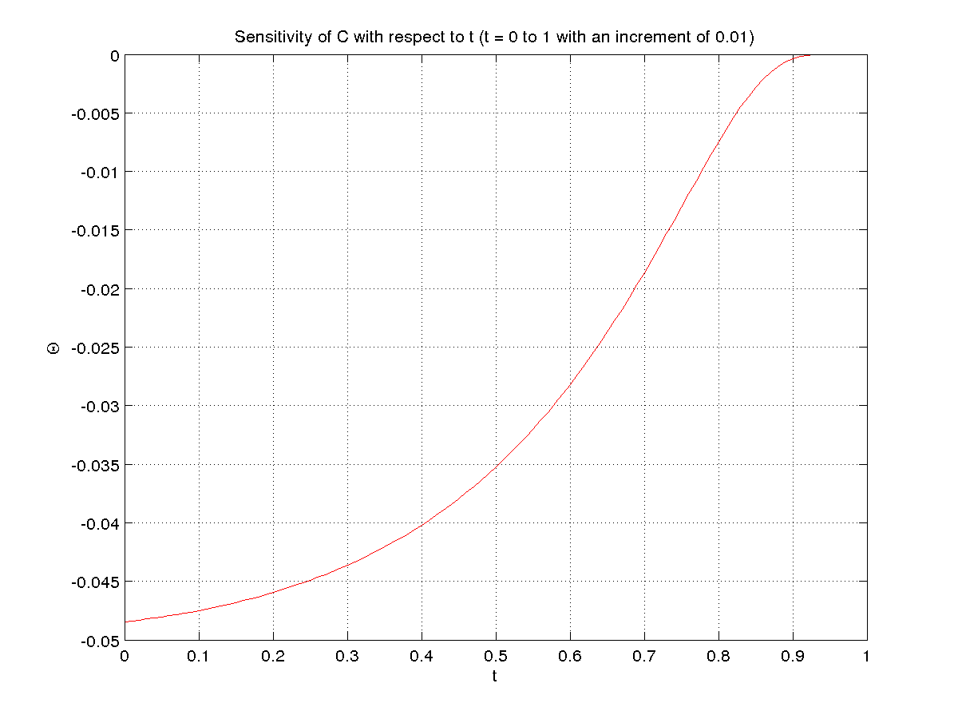
Sensitivity of C for changes in r :-
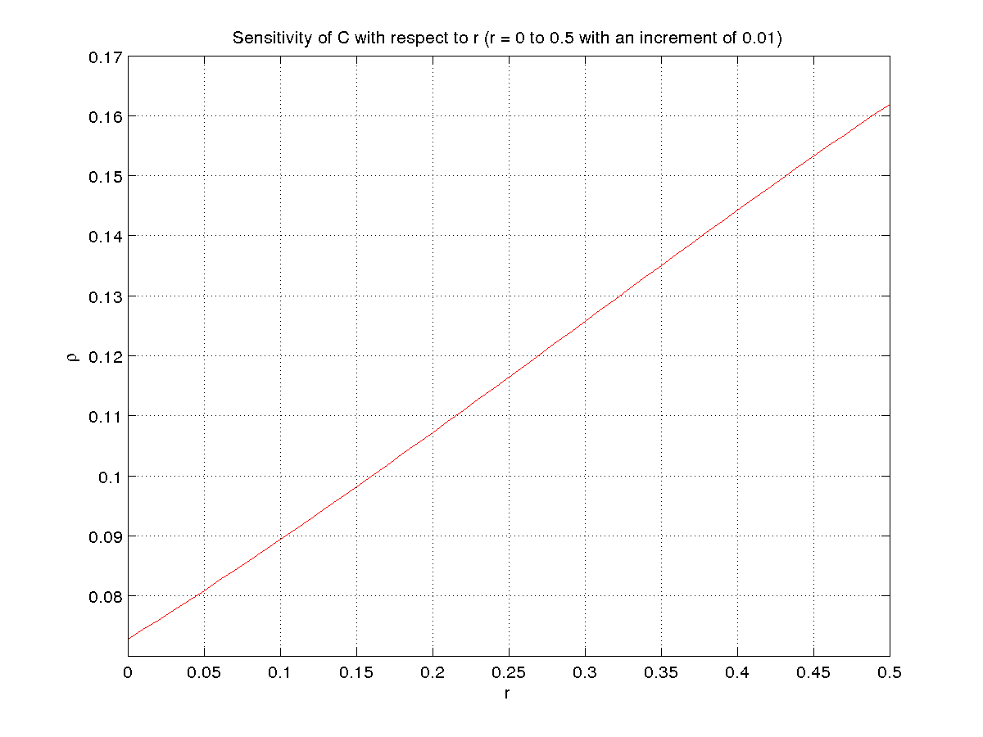

Sensitivity of P for changes in Stock Price :-
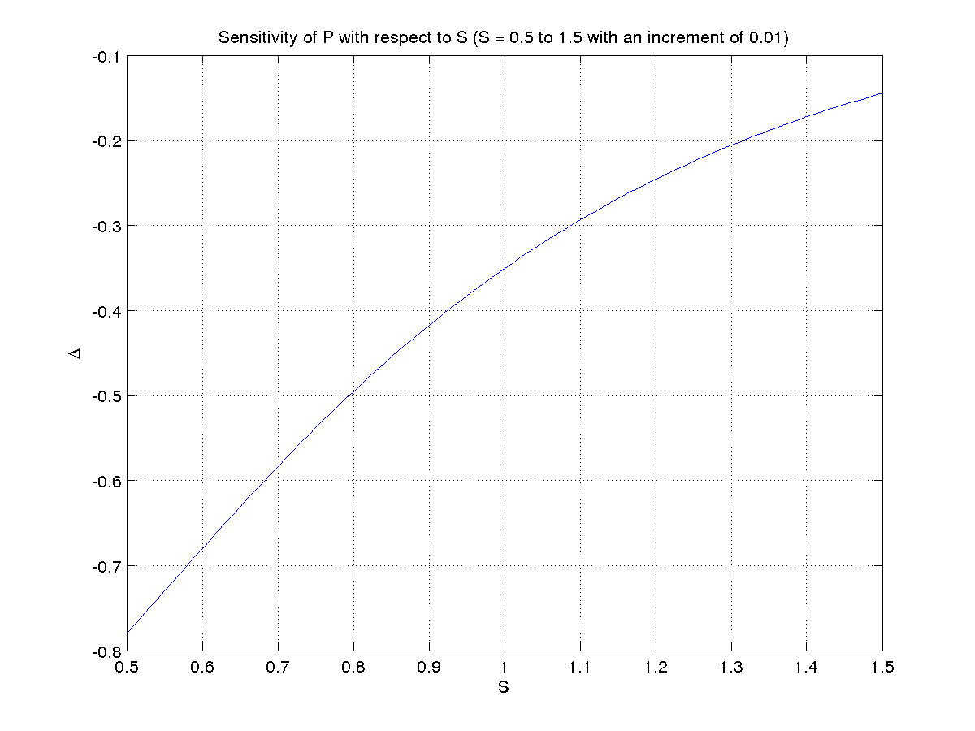
Sensitivity of P for changes in σ :-
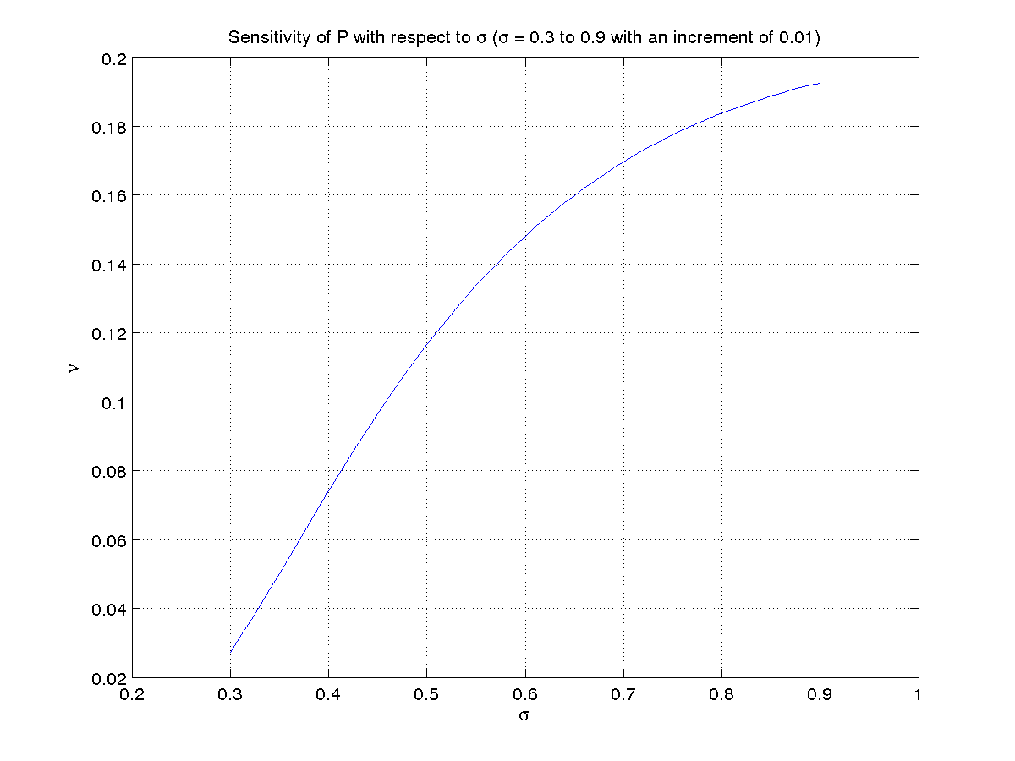
Sensitivity of P for changes in t :-
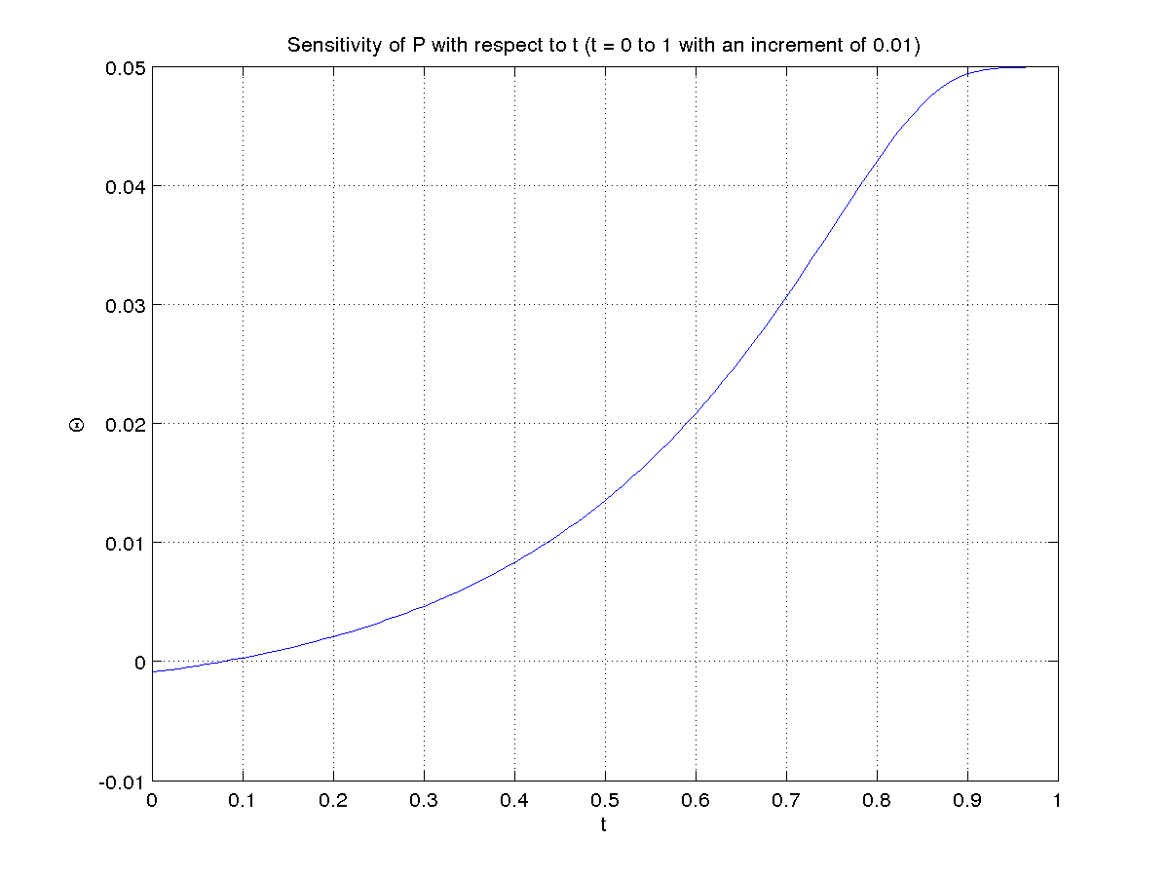
Sensitivity of P for changes in r :-
